GLOBAL FUEL ANALYTICS

Final Project Report
Global Fuel Prices and Taxation Trends (2020–2025)

Project Detail | Information
Prepared by | Akshita Panwar
Team ID | Not assigned (individual project)
Project platform | Tableau Public
Dataset period analysed | 1 Jan 2020 – 31 Dec 2025
Dashboard URL | https://public.tableau.com/app/profile/akshita.panwar/viz/GlobalFuelPricesandTaxationTrends_17930482136410/GlobalFuelPricesandTaxationTrends
Dataset file | global_fuel_prices_Dataset.csv

Prepared for project submission

Contents
1. Introduction
1.1 Project Overview
1.2 Purpose
2. Ideation Phase
2.1 Problem Statement
2.2 Empathy Map Canvas
2.3 Brainstorming
3. Requirement Analysis
3.1 Customer Journey Map
3.2 Solution Requirements
3.3 Data Flow Diagram
3.4 Technology Stack
4. Project Design
4.1 Problem–Solution Fit
4.2 Proposed Solution
4.3 Solution Architecture
5. Project Planning & Scheduling
5.1 Project Planning
6. Functional and Performance Testing
6.1 Performance Testing
7. Results
7.1 Output Charts
8. Advantages & Disadvantages
9. Conclusion
10. Future Scope
11. Appendix

Executive Summary
This project presents a Tableau-based dashboard for exploring global fuel prices and taxation trends from 2020 through 2025. The analysis uses 26,292 records covering 84 countries and 7 regions. It compares petrol, diesel and LPG prices, examines regional differences in average prices and tax percentages, and provides context using Brent crude oil values. The dashboard is intended to make comparisons easier than reviewing separate rows of data. It supports exploration and discussion; it does not establish that tax or crude oil alone causes a change in retail fuel prices.
Dataset check | Result
Records in analysis window | 26,292
Countries | 84
Regions | 7
Date coverage in analysis | 06 Jan 2020 to 29 Dec 2025
Missing cells in filtered dataset | 0
Exact duplicate rows in filtered dataset | 0

1. Introduction

1.1 Project Overview
Global Fuel Prices and Taxation Trends is a data-visualisation project built around a structured dataset of country-level fuel prices, region labels, Brent crude oil values and tax percentages. The Tableau dashboard presents the data through comparisons and trends so users can investigate differences by fuel type, country, region and year.

1.2 Purpose
The purpose is to make fuel-price and taxation information easier to explore, compare and explain. The project supports students and general users who want to understand patterns across locations and time. All prices and calculations should be interpreted according to the dataset’s definitions and units.

2. Ideation Phase

2.1 Problem Statement
Fuel prices and tax percentages vary across countries and over time. When information is stored in a large table, it can be difficult to compare multiple fuel types, years and regions consistently. A consolidated interactive dashboard can reduce this effort by presenting the measures in visual form.

2.2 Empathy Map Canvas
Says | Thinks | Does | Feels
“I want to compare fuel prices by country.” | “Are the values and units comparable?” | Selects a fuel type, country or region. | Wants clear and trustworthy information.
“How much do taxes differ?” | “Which differences need more investigation?” | Reviews charts and compares values. | May be confused by inconsistent coverage or missing context.

2.3 Brainstorming
- Compare petrol, diesel and LPG prices country-wise.
- Show yearly trends for fuel prices and Brent crude oil.
- Compare tax percentages by country and region.
- Use clear titles, units, legends and filters to support exploration.
- Keep the dashboard readable and avoid treating correlation as causation.

3. Requirement Analysis

3.1 Customer Journey Map
Stage | User activity | Dashboard support | Expected outcome
Discover | Opens the dashboard. | Clear title and overview. | Understands the topic.
Explore | Chooses fuel type, year, country or region where available. | Charts and filters. | Finds relevant comparisons.
Compare | Checks prices and tax values across groups. | Side-by-side or ranked charts. | Identifies differences.
Interpret | Reviews trends and regional patterns. | Labels, legends and contextual notes. | Forms cautious observations.
Share | Uses dashboard URL and explains findings. | Public Tableau link and concise summary. | Communicates insights.

3.2 Solution Requirements
Type | Requirement
Functional | Show fuel-price measures for petrol, diesel and LPG.
Functional | Support country-wise and region-wise comparisons where configured.
Functional | Present tax-percentage and Brent crude oil views.
Functional | Use readable titles, labels, units and legends.
Non-functional | Maintain a clear layout and reasonable load/interactivity.
Non-functional | Use consistent numeric formats and avoid unsupported conclusions.
Data | Filter analysis to 2020–2025 for this report; validate source fields and data quality.

3.3 Data Flow Diagram
Step | Process
1. Input | CSV dataset containing date, country, region, fuel prices, Brent crude oil and tax percentage.
2. Preparation | Check column types, date coverage, missing values, duplicates and measure units.
3. Analysis | Aggregate values by year, country, fuel type and region as needed.
4. Visualisation | Build Tableau worksheets and combine selected views into dashboard/story.
5. Output | User explores charts and interprets comparisons through Tableau Public.

Data flow: CSV dataset → data validation/preparation → Tableau worksheets → dashboard/story → user exploration and interpretation.

3.4 Technology Stack
Component | Use
CSV dataset | Structured source data for analysis.
Tableau | Worksheets, comparisons, dashboard and story presentation.
Tableau Public | Publishing and sharing the dashboard online.
Spreadsheet/data checks | Inspect fields, date range, missing values and duplicate records.

4. Project Design

4.1 Problem–Solution Fit
The problem is the difficulty of comparing many fuel-price and taxation records in tabular form. The proposed solution uses visual summaries and interactive exploration to help users find patterns more quickly. The fit is strongest for exploratory comparison and learning; it is not a forecasting or causal-inference system.

4.2 Proposed Solution
- A dashboard overview for global fuel prices and taxation trends.
- Fuel-price comparison views for petrol, diesel and LPG.
- Country-wise and region-wise comparisons.
- Tax-percentage comparisons and regional summaries.
- Brent crude oil trend view to provide additional context.

4.3 Solution Architecture
Layer | Description
Data layer | CSV file with time, country, region and numeric measures.
Preparation layer | Data type checks, date filtering and quality checks.
Visual layer | Tableau worksheets for trends, comparisons and tax views.
Presentation layer | Dashboard/story with labels, filters and public sharing link.
User layer | Viewer selects available filters and compares the displayed results.

5. Project Planning & Scheduling

5.1 Project Planning
Phase | Activities | Deliverable
1. Define | Set project objective and questions. | Project scope.
2. Inspect data | Review columns, date range and quality. | Validated analysis dataset.
3. Design | Select chart types and dashboard structure. | Worksheet plan.
4. Build | Create charts, filters and dashboard/story in Tableau. | Interactive dashboard.
5. Test | Check labels, filters, navigation and values against source data. | Test checklist.
6. Publish | Publish to Tableau Public and verify access. | Public dashboard URL.
7. Report | Document findings, limitations and future improvements. | Final report.

The schedule is a suggested project workflow. Actual completion dates and team IDs should be entered only if confirmed.

6. Functional and Performance Testing

6.1 Performance Testing
Test | How to verify | Status
Dashboard access | Open the published URL in a private/incognito window. | Verify before submission
Chart loading | Confirm each worksheet and dashboard view renders. | Verify before submission
Filter behaviour | Change each available filter and confirm views update consistently. | Verify before submission
Measure accuracy | Compare selected chart values with grouped source-data values. | Verify before submission
Labels and units | Check titles, legends, date ranges and USD/litre or percentage units. | Verify before submission
Navigation/story | Move through dashboard/story pages and check links. | Verify before submission
Responsiveness | Test on laptop and a narrower browser window. | Verify before submission

No measured response-time figures are claimed in this report because no controlled timing test results were supplied. Record actual load times and observed issues during testing rather than entering estimated values as measured results.

7. Results
The filtered dataset for 2020–2025 contains 26,292 rows across 84 countries and 7 regions. The dataset check found no missing cells and no exact duplicate rows in the filtered analysis window. These checks do not by themselves confirm that every value is factually correct.

7.1 Output Charts
Figure 1. Annual average fuel prices (USD per litre).
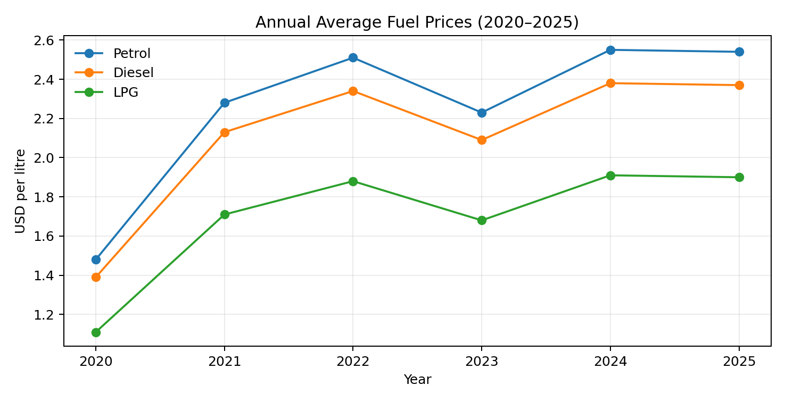
Figure 2. Average petrol price by region.
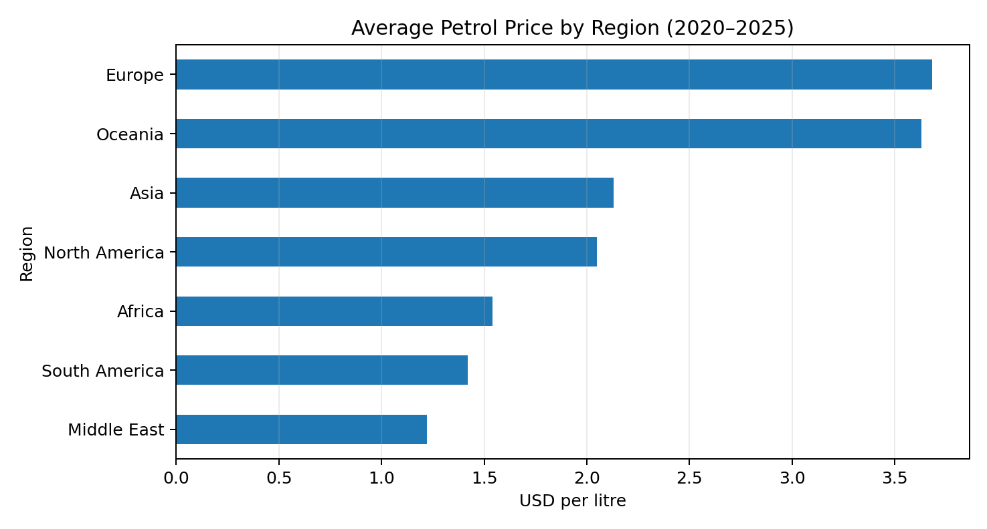

Figure 3. Average tax percentage by region.
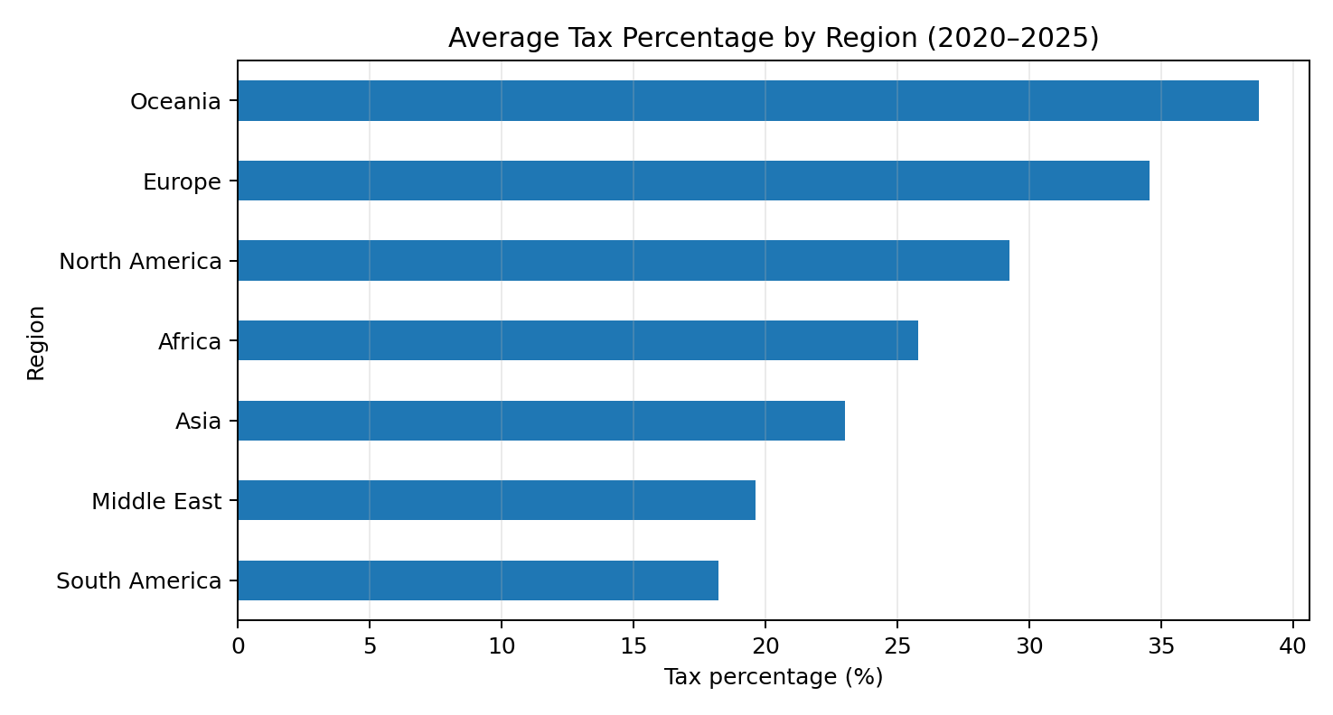
Figure 4. Annual average Brent crude oil value from the dataset.
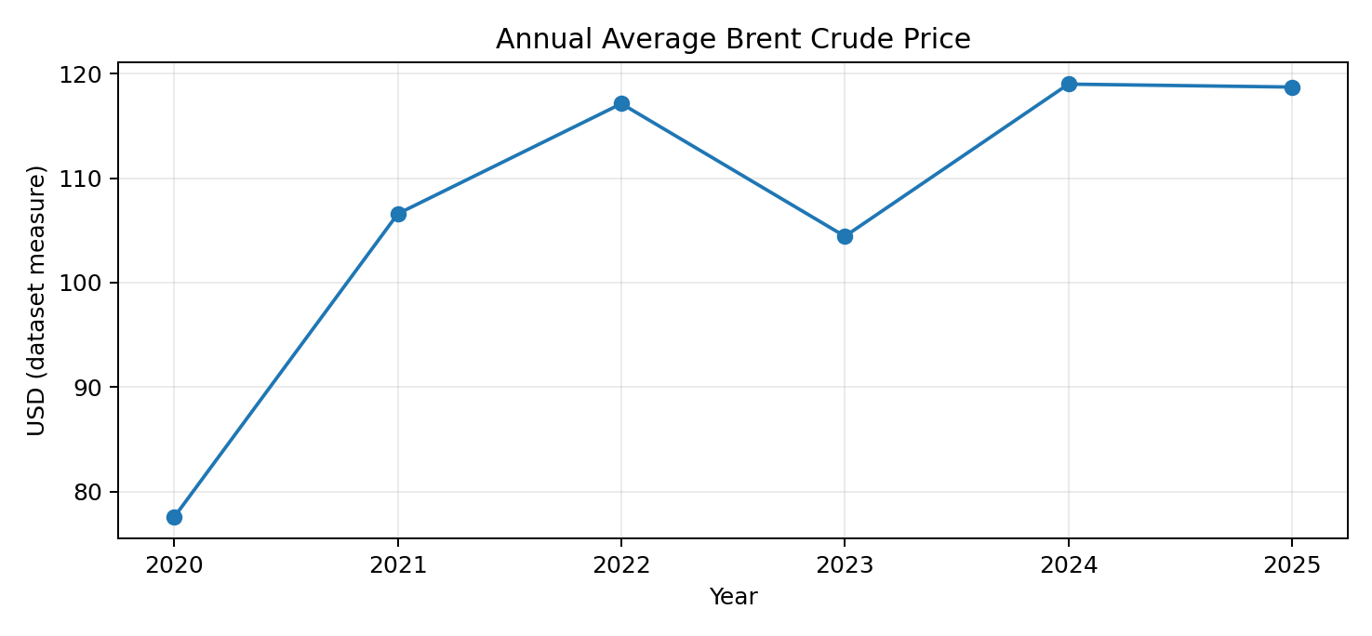

Key observations from the dataset
Across the 2020–2025 analysis window, average petrol price was highest in Europe (3.68 USD/litre) among the regions in this dataset. Average tax percentage was highest in Oceania (38.68%). These are dataset-level averages, not universal prices or official tax estimates.
The annual averages show lower average fuel prices in 2020 than in later years in this dataset. Values vary by fuel type and year; the charts are descriptive and should not be interpreted as proof of a single cause.

8. Advantages & Disadvantages
Advantages | Limitations / disadvantages
Makes multi-country comparisons easier. | Interpretation depends on dataset definitions and coverage.
Combines several fuel measures and tax percentages. | Averages can hide local and within-year variation.
Visual trends can support discussion and presentations. | Charts alone do not establish causality or forecast prices.
Public dashboard can be shared online. | Requires internet access and a working Tableau Public link.
Structured quality checks improve transparency. | Live dashboard performance still needs hands-on verification.

9. Conclusion
The project demonstrates how Tableau can turn a large fuel-price dataset into visual comparisons across fuel types, countries, regions and years. The 2020–2025 analysis includes 26,292 records and provides descriptive views of fuel prices, tax percentages and Brent crude oil values. The dashboard is a useful exploratory aid when the data source, units and limitations are kept clear.

10. Future Scope
- Add clear source citations and a data dictionary for each field and unit.
- Add a dedicated year selector and consistent date controls across views.
- Provide downloadable summary data or a methodology note.
- Improve mobile layout and test dashboard accessibility.
- Add validation rules for implausible values and compare the dataset with authoritative sources.
- If forecasting is required, build and validate a separate model rather than implying that the current dashboard predicts prices.

11. Appendix

Source Code (if any)
The primary deliverable is a Tableau dashboard. No separate source-code repository was provided with this report.

Dataset Link
Dataset file supplied for the project: global_fuel_prices_Dataset.csv (local project file). Add the original public dataset URL here if required by the evaluator.

GitHub & Project Demo Link
Tableau Public dashboard:
https://public.tableau.com/app/profile/akshita.panwar/viz/GlobalFuelPricesandTaxationTrends_17930482136410/GlobalFuelPricesandTaxationTrends
GitHub repository: not provided; add the repository URL if one exists.

Submission note: The uploaded Project Report Format PDF is a contents/outline page and contains no visible logo artwork. This report follows its section structure and does not add, replace, or alter any logo. Insert actual Tableau dashboard screenshots if the evaluator specifically requires screenshots of the live dashboard.

